AIM: TO IMPLENT 16 BIT SUBTRACTION USING 8086 PROCESSOR

1. ALGORITHM: Load 0000H into CX register (for borrow)
2. Load the data into AX(accumulator) from memory 3000.
3. Load the data into BX register from memory 3002.
4. Subtract BX with Accumulator AX.
5. Jump if no borrow.
6. Increment CX by 1.
7. Move data from AX(accumulator) to memory 3004.
8. Move data from CX register to memory 3006

PROGRAM:

MOV AL,06H

MOV BL,0AH

SUB BL,AL

MOV CX,00008H

PRINT:MOV AH,02H

MOV DL,030H

TEST BL,080H

JZ ZERO

MOV DL,031H

ZERO:INT 021H

SHL BL,1

LOOP PRINT

MOV DL,062H

INT 016H

RET

NOP

NOP

NOP

RET

INPUT: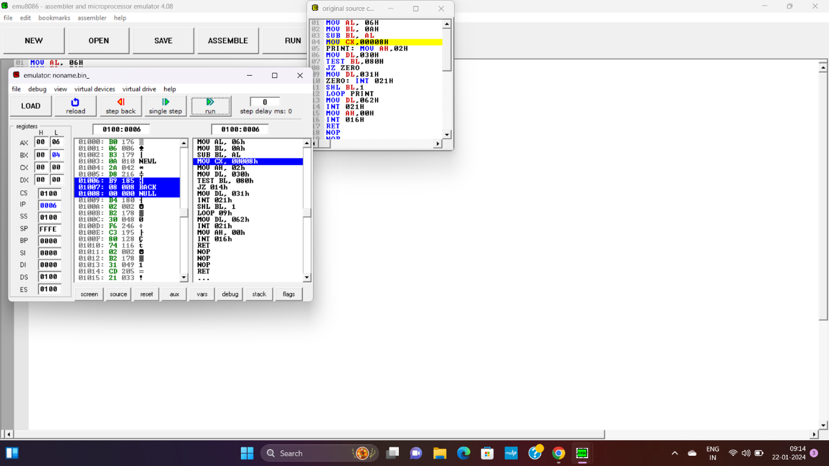

RESULT: TUS THE PROGRAM WAS EXECUTED SUCESSFULLY USINIG 8086 PROCESSOR

OUTPUT: